Hi Vincent

I would like to see something similar with our old website backend. All features and functions are much clear and easier than Magento.

In the order page, you can move these function bar to the top of the page (like Magento)

Something like this:

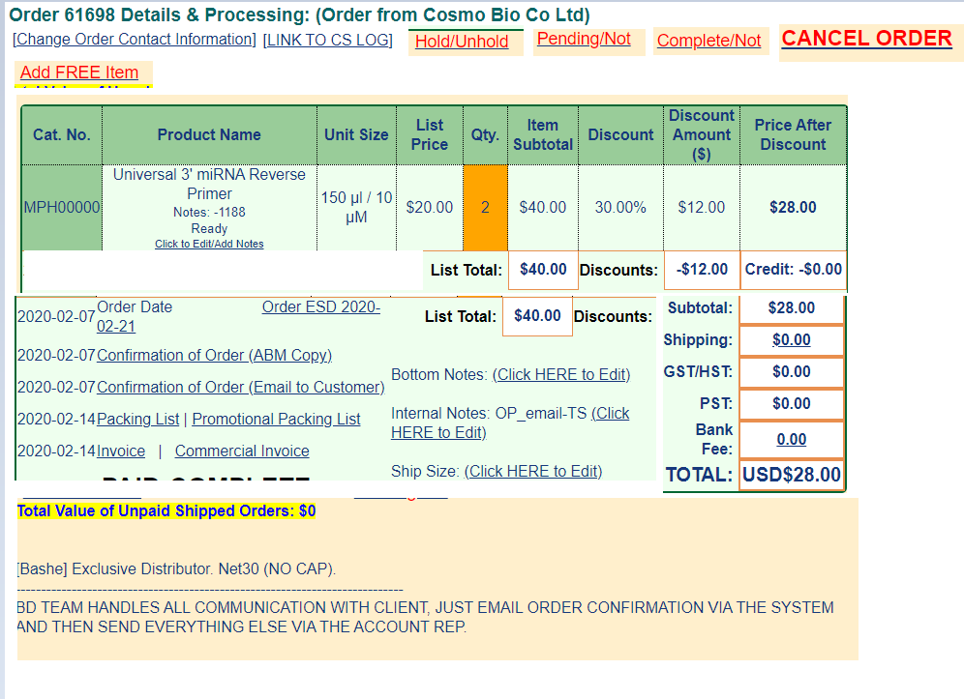

1. All functions button on the top, can direct access CSL without extra step.

2. For order contact information, cannot be saved if missing any information. (etc. TAX ID)

3. For order date, confirmation date, packing list date and invoice date show on the left.

4. For packing list, can choose any date like following:

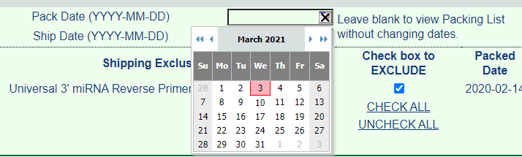

5. add any order notes to the to the notes section:

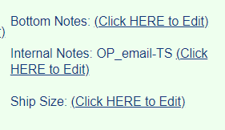

6. put customer special instruction notes to the bottom:

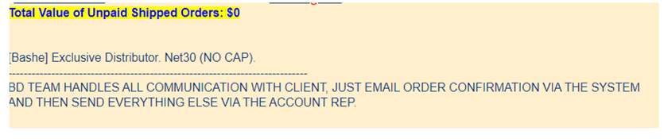

7. Can edit or add special note for each product they ordered:

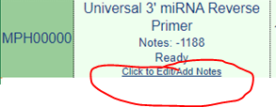

---\* easy to see order products (you don’t have to move all the way down to see the products like Magento)

------------------------------------------------------------------------------------------------------------------------------------------For inventory search section:

Both old website and Magento are pretty clear and easy to use:

All products components will be shown and how many vials contains in each kit. Location, stock number, unit size, price, supplier and location.